The web application is using http instead of https.

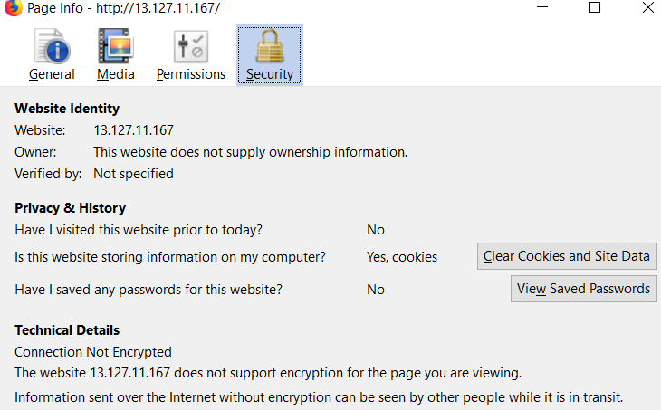

Default Wonder CMS password is displayed publicly.



Instructions to update the Wonder CMS and edit the webpages is given publicly.

